Session 5 Online Diary – Twitch Skill

Cory Arnett-O’Brien

ID:20158721

# 4.0 Game Premise

The game is played by having players generate random criteria, and then they must find images to match those criteria using the internet bonus points can be warded for fining “good” images as decided by the other players, another was to get bonus points it to create a story to go along with the pictures found

# 4.1 Materials

This prototype game was created using Construct 3 and required each player to have access to a web browser to find images

# 4.2 Basic Rules

The game can be played with between 2 and 4 players​

Each player must find three images that match the randomly assigned criteria

Each image must match two different criteria that are generated when the game starts (all players have the same criteria)

The players must find images of real-life and cannot use stock photographs

The first player to find all three images wins.​

After playing a few games player may wish to progress on to playing with the advanced rules

# 4.3 Advanced Rules

Optional advanced rules. These rules are for players who have played the game a few times and are looking for an extra challenge

Bonus Round rules:

The player who found all their images first gets 2 points. ​

Players vote on which player found the best image (players cannot vote for themselves), the player who found the image gets one bonus point (requires three or more players).​

Players can create a story to go with their image, the players vote on the best story, and that player gets two bonus points (this means creating a good story is as valuable as finding the images first). ​

If two players have equal points the game ends in a tie otherwise the player with the most points wins.​

# 4.4 How to use the software

Figure 1:

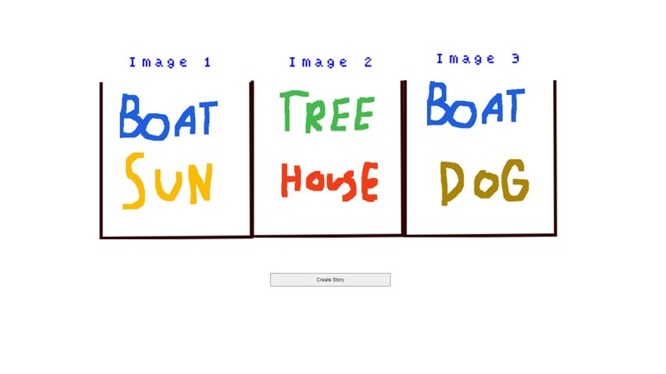

**A**

**B**

**C**

Figure 1 **A**-One image criteria, **B**-Randomise criteria button, **C**-Complete image criteria

To use the software, wait until all players are ready, then click the randomise criteria button labelled “Create Story.”

# 4.5 Play Testing

Internal playtesting:​

During the internal playtesting using the advanced rules, it was discovered that voting on the best image or story did not work with two players as both players would tie. It was also discovered that it was possible to get two of the same criteria for and image, this was later fixed in the prototype version.​

External playtesting: playing with the simple rules. “I like the fact that it is a minimum of two players”, “I like the simplicity of the game”-Zakaria Ahmed​

# 4.6 Teamwork

Communication between team members was not efficient, and few changed were made to the overall design after the playtesting feedback as by the time playtesting had been completed there was little time left to make adjustments.

# 4.7 Team members

Developers: Cory Arnett-O’Brien, Sienna Jenkins, Jamie Soden ​

Playtesters: Zakaria Ahmed​

​